The main page of globe.com.ph contains a lot promos that they are selling and contains
a services that they promoting for there costumers.
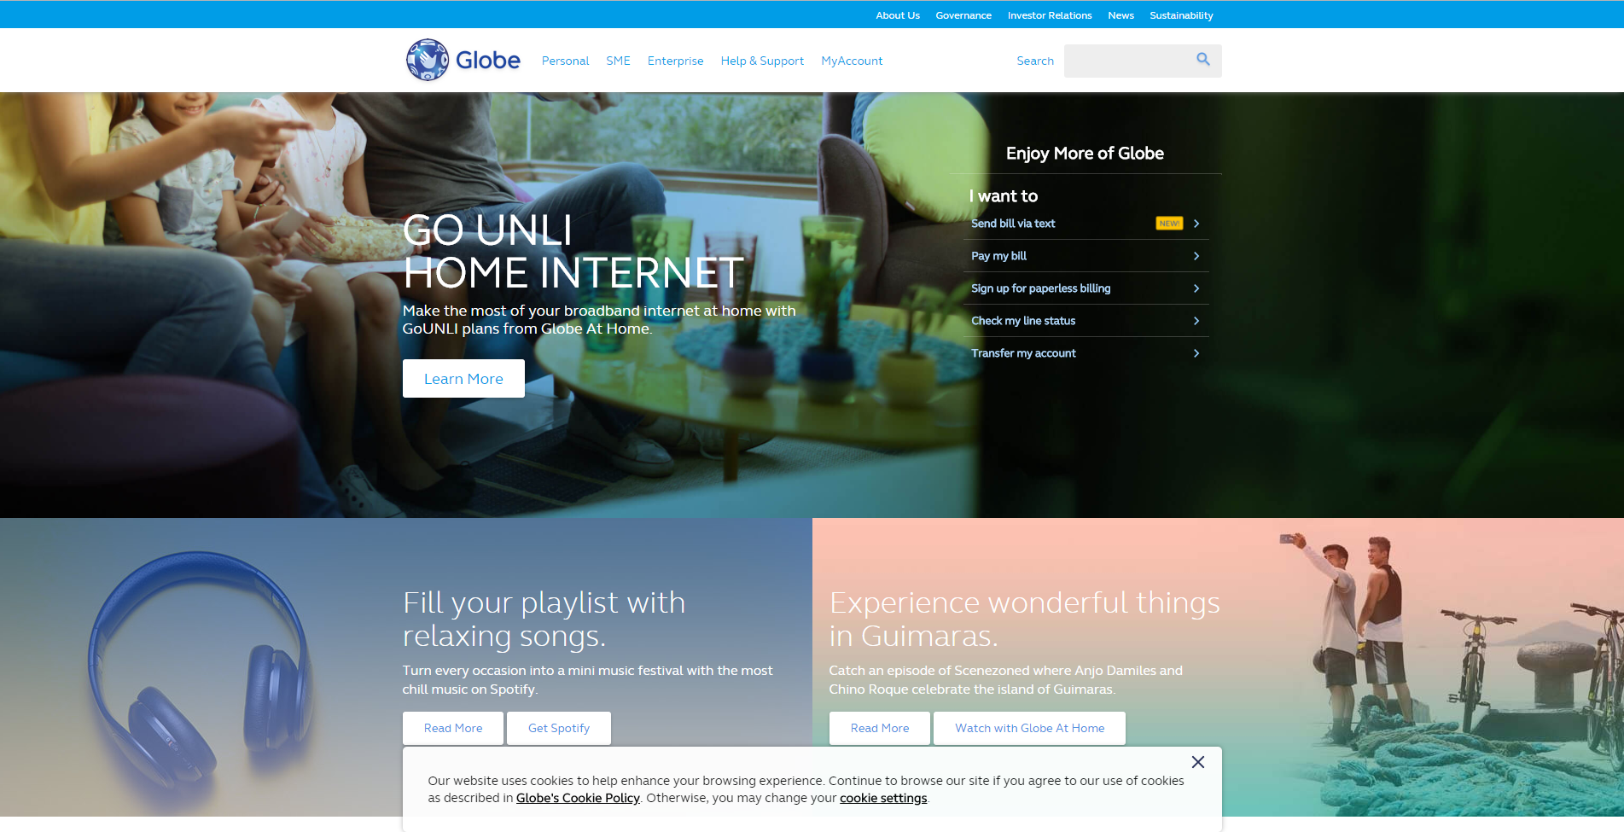
Clean font

Irritable
Color

The secondary page of globe.com.ph/prepaid is a simple website where the costumer can learn
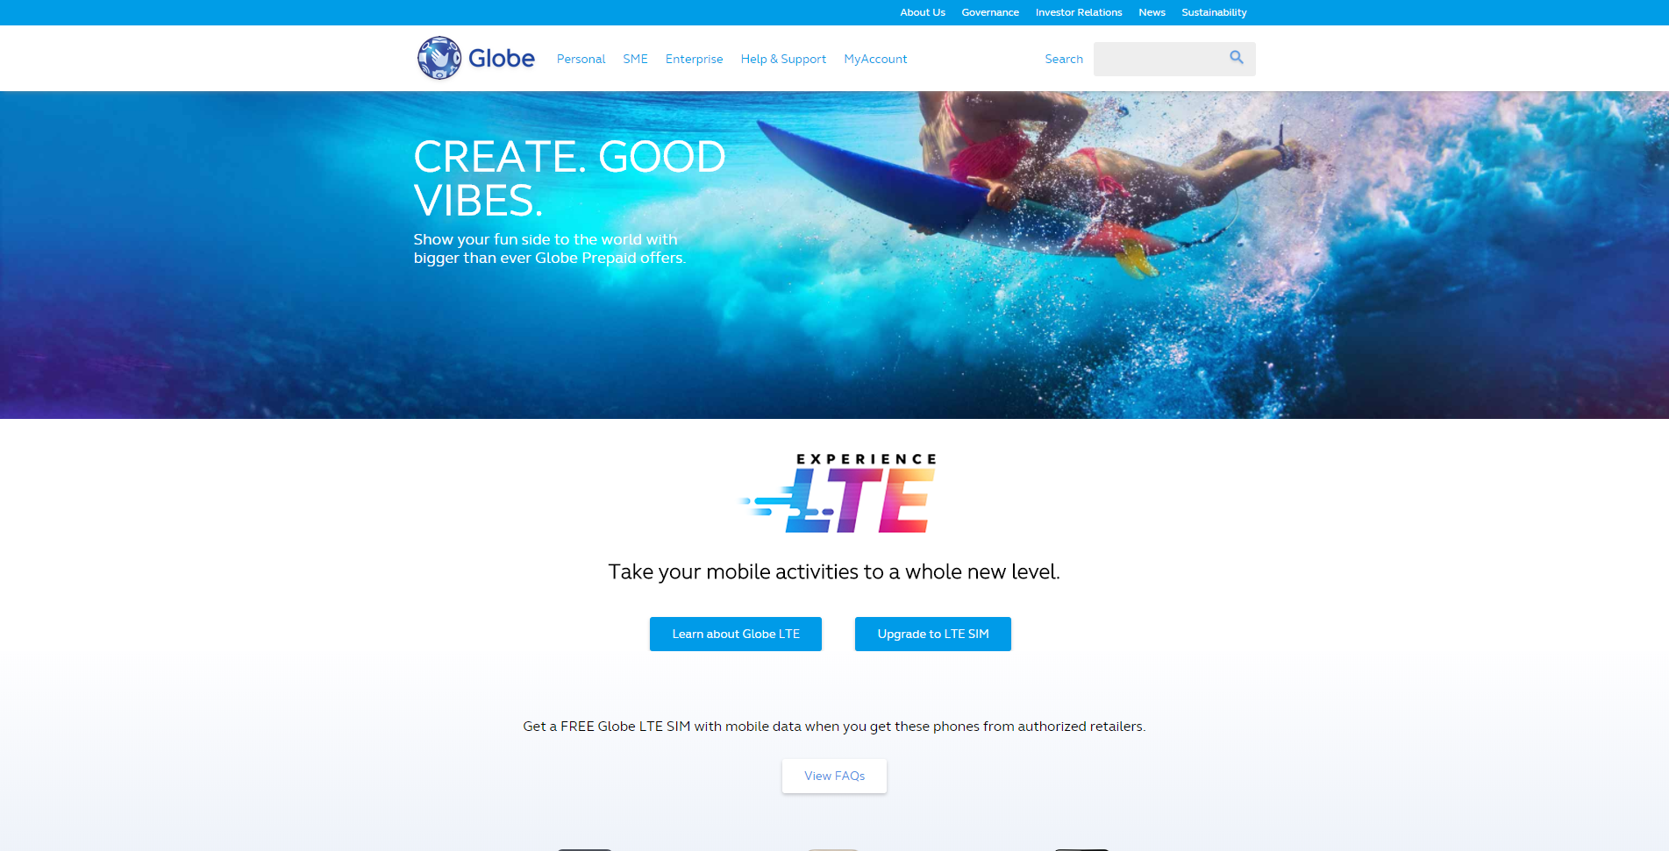
about LTE Sim and where you can upgrade your sim to a LTE sim that the globe was promoted.
Too much
whitespace

